Hello, my name is _____. Today I’m going to be interviewing you about some things related to food delivery. I’m first going to ask you a screening question, and then we’ll get into the interview.
Is it okay if I record this interview?
- If yes, start recording
- If no, do not record and take notes via computer
Screening Question
- In the past six months, have you ordered food online using an app?
  - If yes, they qualify for this interview. Interviewer says, “This means you qualify for this interview. I’m now going to ask you some more questions.”
  - If not, they do not qualify. Interviewer says, “This answer means you are not in the group of people we are looking to interview further for this project. Thanks for your time.” [ answer any questions they may have and say goodbye]
Demographics Questions
- How old are you?
- Where do you live?
Interview Questions
- Please tell me about the last time you ordered food online. Start by sharing why you decided to order what you ordered and talk me through the entire process of ordering, waiting for your order, receiving your order, and whatever you did after you received the order. Please include as much detail as possible about each step in this process and also any notable changes in your emotions throughout the process.
  - In this process, what did you enjoy the most? The least?
- What are the main reasons you order food online?
  - Why?
- What device do you typically use to order food online? (expected answer: smartphone or computer)
  - Why?
- How do you order food online? (expected answer: app, website, etc)
  - Why?
- What food delivery apps are your favorite?
  - Why?
- What features in that/ those apps do you appreciate the most?
  - Why?
- Are there any features you’d like to see in a food delivery app that don’t currently exist?
  - Why?
- What food delivery apps are your least favorite?
  - Why?
- What stand-out features or capabilities lead you to choose one food delivery app over another?
  - Why?
- What time of the day and/or days of the week do you typically order food online?
  - Why?
  - How often?
  - Why?
- What are your thoughts about having a small dog-sized robot deliver your food? *show picture of robot*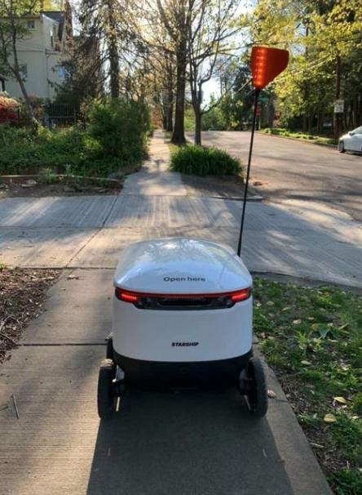

  - Why?
- What would you appreciate about receiving food delivery from a robot?
  - Why?
- What would you not appreciate about receiving food delivery from a robot?
  - Why?
- Is there anything else you’d like to share with me about food delivery or robot delivery services?
Thank you for your time. Please don’t hesitate to reach out to me if you think of anything else related to these topics that you would like to share.
Next, we’re going to look at a robot delivery service app.

